Assignment 5: Bayesian Networks’s Solution

Part 1 Solution
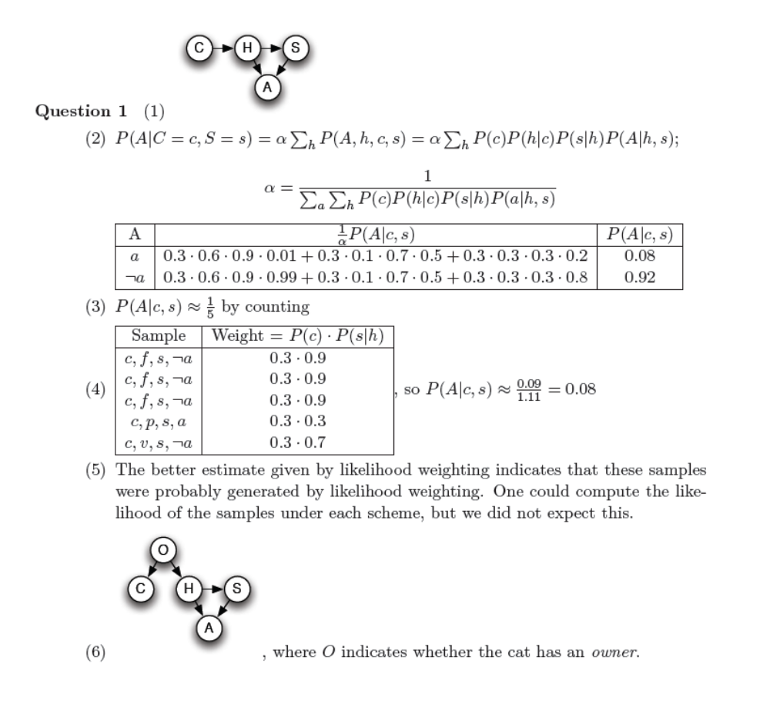

Question 2
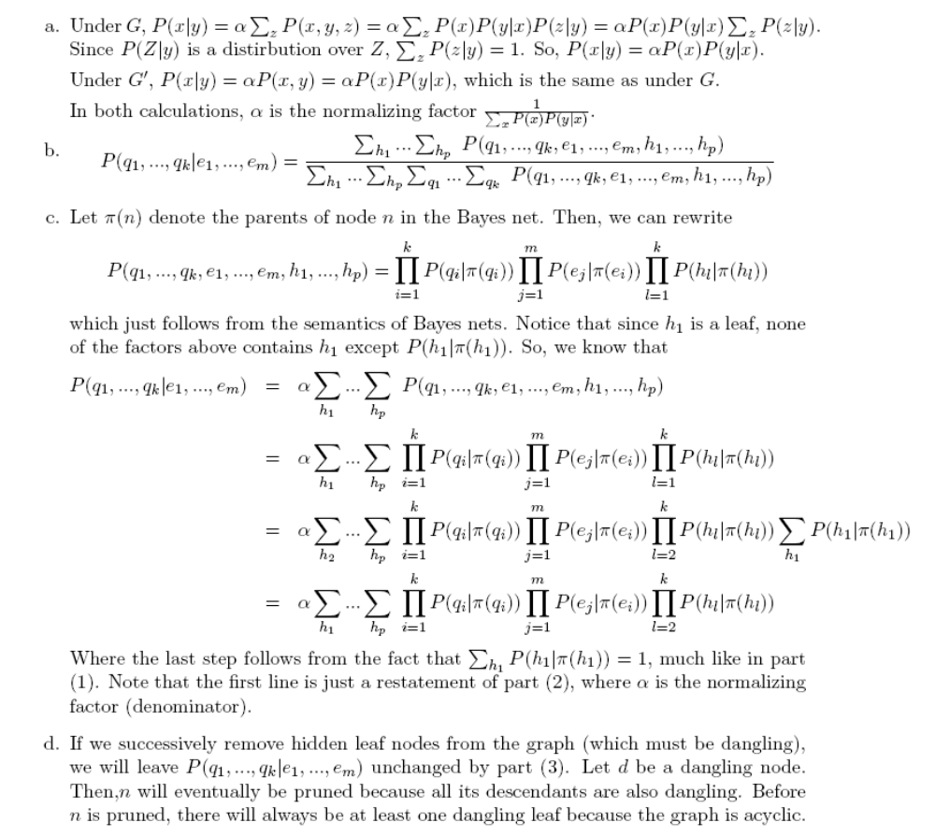

Part 2 Solution

class ExactStaticInferenceModule(StaticInferenceModule):
"""
You will implement an exact inference module for the static battleship game.

See the abstract 'StaticInferenceModule' class for descriptions of the methods.

The current implementation below is broken, returning all uniform distributions.
"""

def getShipTupleDistributionGivenObservations(self, observations):

# BEGIN SOLUTION

p_ShipTuple_and_observations = Counter()
p_ShipTuple = self.game.getShipTupleDistribution()
for shipTuple in self.game.getShipTuples():
p = p_ShipTuple.getCount(shipTuple)
for observation in observations.items():
sensor, reading = observation
p_Reading_given_shipTuple = self.game.getReadingDistributionGivenShipTuple(shipTuple, sensor)
p_reading_given_shipTuple = p_Reading_given_shipTuple.getCount(reading)
p *= p_reading_given_shipTuple
p_ShipTuple_and_observations.setCount(shipTuple, p)
p_ShipTuple_given_observations = normalize(p_ShipTuple_and_observations)
return p_ShipTuple_given_observations

# END SOLUTION

def getReadingDistributionGivenObservations(self, observations, newLocation):

# BEGIN SOLUTION

oldReadingForNewLocation = self.fetch(newLocation, observations)
p_NewReading_and_observations = Counter()
p_ShipTuple_given_observations = self.getShipTupleDistributionGivenObservations(observations)
for shipTuple, p_shipTuple_given_observations in p_ShipTuple_given_observations.items():
p_Reading_given_shipTuple = self.game.getReadingDistributionGivenShipTuple(shipTuple, newLocation)
for reading in Readings.getReadings():
p_reading_given_shipTuple = p_Reading_given_shipTuple.getCount(reading)
if oldReadingForNewLocation != None:
p_observation_given_ship = 0.0
if oldReadingForNewLocation == reading:
p_observation_given_ship = 1.0
p_NewReading_and_observations.incrementCount(reading, p_shipTuple_given_observations * p_reading_given_shipTuple)
p_NewReading_given_observations = normalize(p_NewReading_and_observations)
return p_NewReading_given_observations

# END SOLUTION

# BEGIN SOLUTION

def fetch(self, key, pairList):
for key2, value2 in pairList:
if key == key2: return value2
return None

# END SOLUTION

class StaticVPIAgent(StaticBattleshipAgent):
"""
Computer-controlled battleship agent.

This agent plays using value of (perfect) information calculations.

The initial implementation is broken, always taking a random bombing action
without sensing. You will rewrite it to greedily sense if any sensing action
has an expected gain in utility / score (taking into account the cost of
sensing). If no sensing action has a greedy gain, then you will select a
position tuple to bomb. In this case, your agent should bomb the tuple with
the highest expected utility / score according to its current beliefs.
"""

def getAction(self):

# BEGIN SOLUTION

self.game.display.pauseGUI()
observations = self.observations
expectedUtilities = self.getExpectedUtilities(observations)
currentBestEU, currentBestBombingOptions = maxes(expectedUtilities)
utilityGain = Counter()
for location in self.game.getLocations():
if location in observations.keys(): continue
expectedNewMEU = 0
p_Reading_given_observations = self.inferenceModule.getReadingDistributionGivenObservations(observations, location)
for reading in Readings.getReadings():
outcomeProbability = p_Reading_given_observations.getCount(reading)
if outcomeProbability == 0.0: continue
newObservations = dict(observations)
newObservations[location] = reading
outcomeExpectedUtilities = self.getExpectedUtilities(newObservations)
outcomeBestEU, outcomeBestActions = maxes(outcomeExpectedUtilities)
expectedNewMEU += outcomeBestEU * outcomeProbability
utilityGain[location] = expectedNewMEU - currentBestEU - abs(SENSOR_SCORE)
bestGain, bestSensorLocations = maxes(utilityGain)
if bestGain > 0:
return [Actions.makeSensingAction(l) for l in bestSensorLocations]
return [Actions.makeBombingAction(o) for o in currentBestBombingOptions]

# END SOLUTION

# BEGIN SOLUTION
def getExpectedUtilities(self, observations):

p_ShipTuples = self.inferenceModule.getShipTupleDistributionGivenObservations(observations)
expectedUtilities = Counter()
for option in self.game.getBombingOptions():
expectedUtility = 0
for ships in p_ShipTuples.keys():
p = p_ShipTuples[ships]
utility = BATTLESHIP_SCORE * self.numMatches(option, ships)
expectedUtility += p * utility
expectedUtilities[option] = expectedUtility
return expectedUtilities

def numMatches(self, option, ships):
matches = 0
for ship in ships:
if ship in option:
matches += 1
return matches

# END SOLUTION

